Computer vision assignment
Download the assignment package for your operating system ( Linux, Windows) and unzip it. The package contains a viewer application together with the input data required for the task, including three point cloud files (image1.ply, image2.ply, image3.ply) and a trajectory file (traj.txt). The viewer loads the point clouds and camera poses from those files.
After unzipping, you have the following folder structure:

Windows | Linux
+---ComputerVisionAssignment_Data  | +---Managed  | +---Plugins  | +---Resources  | +---StreamingAssets  | | +---aa  | | +---Points  | | | +---image1.ply  | | | +---image1.png  | | | +---image1_depth.png  | | | +---image1_rays.png  | | | +---image2.ply  | | | +---image2.png  | | | +---image2_depth.png  | | | +---image2_rays.png  | | | +---image3.ply  | | | +---image3.png  | | | +---image3_depth.png  | | | +---image3_rays.png  | | +---traj.txt  +---D3D12  +---MonoBleedingEdge  +---ComputerVisionAssignment.exe  +---UnityCrashHandler64.exe  +---UnityPlayer.dll | +---ComputerVisionAssignment_Data  | +---Managed  | +---MonoBleedingEdge  | +---Plugins  | +---Resources  | +---StreamingAssets  | | +---aa  | | +---Points  | | | +---image1_depth.png  | | | +---image1.ply  | | | +---image1.png  | | | +---image1_rays.png  | | | +---image2_depth.png  | | | +---image2.ply  | | | +---image2.png  | | | +---image2_rays.png  | | | +---image3_depth.png  | | | +---image3.ply  | | | +---image3.png  | | | +---image3_rays.png  | | +---traj.txt  +---ComputerVisionAssignment.x86_64  +---libdecor-0.so.0  +---libdecor-cairo.so  +---UnityPlayer.so

Relevant data is marked in yellow, while the executable of the viewer is marked in green. The application loads in the 3 imageN.ply containing local space point clouds generated from monocular images, and the traj.txt file containing the world space camera poses for the relevant images.
Sadly, the systems producing the data and the viewer application are not using the same coordinate system.

Objective
Create a program that converts the provided data into the coordinate system expected by the viewer. Your solution must produce replacement versions of: image1.ply, image2.ply, image3.ply, traj.txt.
The transformed files should be geometrically consistent with one another and display correctly in the viewer. The exact difference between the source and viewer coordinate systems is intentionally not specified. Determining the required transformation is part of the assignment. You may use any programming language.
Once completed, the viewer should be able to see a similar result to the image below.

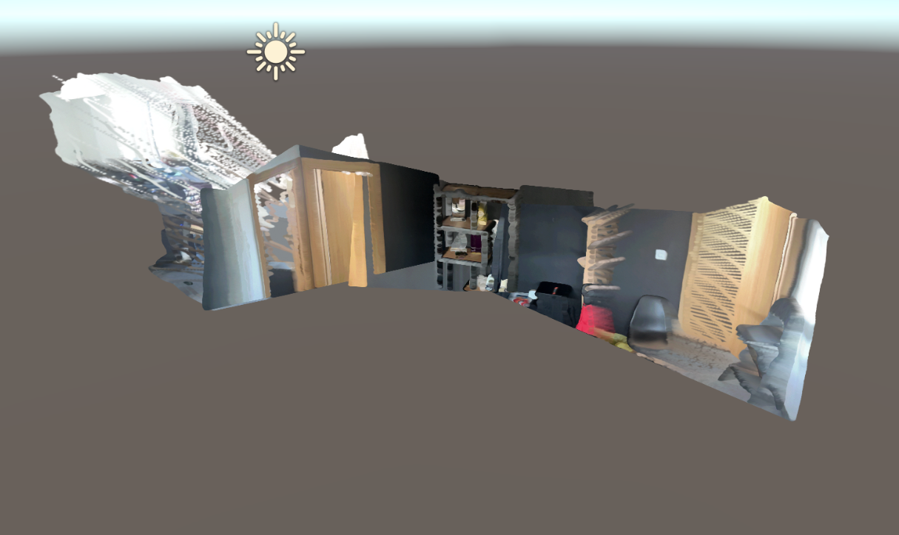

Viewer Notes
Use the viewer to inspect your result.
- Hold the right mouse button to rotate the view
- While holding the right mouse button, use:
  - W / A / S / D to move
  - Q / E to move up and down

Submission
Please submit your results regardless of whether you succeeded in finding the correct result:
- a short README describing your approach to searching for the solution
- the source code for your solution and instructions on how to run it

